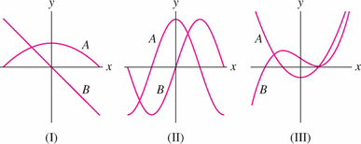
- Each graph shows the graph of a function f (x) and its derivative f(x). Determine which is the function and which is the derivative.

- Is (A), (B), or (C) the graph of the derivative of the function f (x) shown?
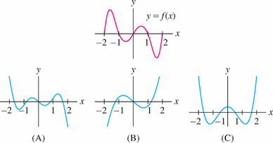

- Match the functions in graphs (A)–(D) with their derivatives (I)–(III). Note that two of the functions have the same derivative. Explain why.
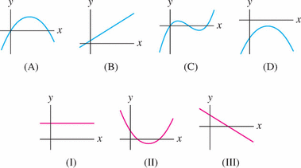

- Of the two functions f and g which is the derivative of the other? Justify your answer.
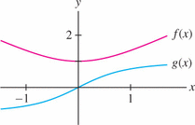

- Match functions (A)–(C) with their derivatives (I)–(III)
