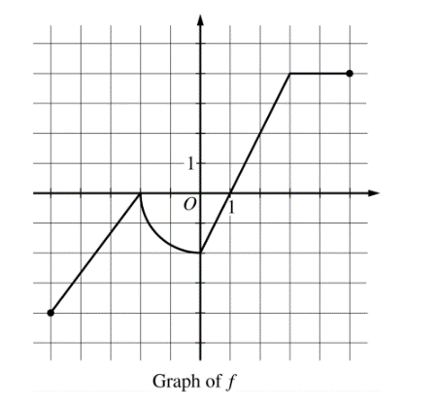
Name ___________________________________________________________________________________________
AP Calculus Unit 6a Practice Test Free Response NO CALCULATOR

- Determine the absolute maximum value of g on the closed interval $-5≤x≤5$. Justify your answer.

